From mountain to sea

Aberchirder Primary School
Safeguarding and Child Protection Policy
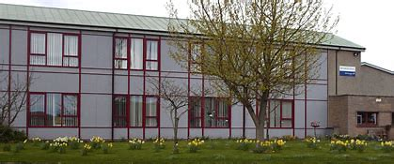

1st November 2021

Contact Details

Child Protection Lead: a member of the senior leadership team with appropriate authority, responsible for dealing with CP issues, providing advice and support to other staff, liaising with the local authority, and working with other agencies. This is a post which requires assessment of children.

Name: 1st: Lisa Campbell (Head Teacher)

Deputy Child Protection Lead: a member of staff with appropriate authority, responsible for dealing with CP issues, providing advice and support to other staff, liaising with the local authority, and working with other agencies in the absence of the CP lead.

Name: Jennifer Astridge (Acting Head Teacher) Claire Carré (Nursery Manager)

All School-based staff can be contacted using the following details:

Tel: 01466 405920
Email: aberchirder.sch@aberdeenshire.gov.uk
Address: Smith Crescent. Aberchirder. AB54 7TW

Introduction

Safeguarding and Child Protection is part of our approach to getting it Right for Every Child (GIRFEC), the UN Convention on the Rights of the Child and Curriculum for Excellence. Every child and young person has the right to be safe, healthy, active, nurtured, achieving, responsible, respected and included. They have the right to be listened to and to have their views considered.

Article 3 The best interests of the child must be a top priority in all things that affect children.

Article 12 Every child has the right to have a say in all matters affecting them, and to have their views taken seriously.

Article 13 Every child must be free to say what they think and to seek and receive all kinds of information, as long as it is within the law.

Article 19 Governments must do all they can to ensure that children are protected from all forms of violence, abuse, neglect and bad treatment by their parents or anyone else who looks after them.

Article 36 Governments must protect children from all other forms of bad treatment.

Additionally, at Aberchirder (linked to the UNCRC) our aims are to:
- Foster a mutual respect for the rights of all pupils and staff, ensuring inclusion for all (ARTICLES 4 and 28)
- Encourage everyone to take responsibility for their actions, choices and daily lives (ARTICLES 12 and 19)
- Encourage a passion for learning (ARTICLES 5 and 29)
- Create opportunities to work together, in partnership with our community and our families (ARTICLES 2, 15 and 29)
- Embrace challenges and conquer difficulties (ARTICLES 28 and 29)

Staff and volunteers in schools are well-placed to observe physical, psychological or emotional changes in children that may indicate some form of abuse. All staff should familiarise themselves with the
Aberdeenshire Council Protecting Children and Young People in Education documents, located in the School SharePoint under School Policies. Categories of child abuse listed in the guidelines are physical injury, non-organic failure to thrive, emotional abuse/neglect, sexual abuse and physical neglect. Where there is a possibility that a child could be at risk, the school is required to follow strict procedures which are outlined in this policy. Any intervention by a public authority in the life of a child must be properly justified and should be supported by services from all relevant agencies working in collaboration.
Children have the right to be protected from abuse and harm at all times. Schools are responsible for ensuring that children are protected from maltreatment so that they grow and develop appropriately. This policy guides the school in protecting those rights to help ensure that every child is kept safe. This helps our children have the best start in life, to develop and become:

- Responsible citizens
- Successful learners
- Confident Individuals
- Effective Contributors.

Definitions

Child Protection- In the context of these guidelines, the term ‘Child Protection’ incorporates suspected and actual abuse of children. Someone may abuse or neglect a child by inflicting, or by failing to act to prevent, significant harm to the child.

Safeguarding - Safeguarding is a much wider concept than child protection and refers to promoting the welfare of children. It encompasses the following: protecting children from maltreatment; preventing impairment of children’s health or development; ensuring that children are growing up in circumstances consistent with the provision of safe and effective care and taking action to enable all children and young people to have the best outcome. Child protection is part of this definition and refers to activities undertaken to prevent children suffering, or likely to suffer, significant harm.
Child Protection and Safeguarding Policy (2018), Education Scotland.

At Aberchirder Primary School, we will:
- Prioritise the safety and wellbeing of each child. Management of suspected abuse must put the safety of the child first.
- Ensure all staff are responsible for the implementation of procedures. Prevention of abuse is as important as reacting to suspicions of abuse.
- Ensure the child’s views are listened to and taken seriously.

These are always in line with our school’s: Vision - ‘Yes we can’,
&
Our values - PRAISE

Persevere Respect and Responsibility Attitude Included Safe enthusiastic

GIRFEC - Getting It Right For Every Child

The Scottish Government’s policy for all children’s services sets out the following vision, that all children’s services will:

Put the child and their family at the centre
- Provide early intervention in order to ensure that all children achieve their potential
- Achieve the highest standards of joint working and collaboration to improve outcomes for all children
- Ensure a single planning process is in place for children and young people

In order to achieve their potential Children and Young people need to be:

- Safe
- Healthy
- Achieving
- Nurtured
- Active
- Respected
- Responsible
- Included

These are known as the SHANARRI wellbeing indicators. See Appendix 1.

If a staff member feels that a child or young person’s wellbeing is being affected, then they should ask the five GIRFEC questions:

  - What is getting in the way of this child or young person’s wellbeing?
  - What can I do now to help this child or young person?
  - What additional help – if any – may be needed from others?
  - Do I have all the information I need to help this child or young person?
  - What can my agency do to help this young child or young person?

It is vital that all staff know what action to take should they have any concerns about a child or should they receive information which suggests that the child may be experiencing some form of abuse. The procedures outlined in this policy are designed both to safeguard the wellbeing of the child and to ensure that all school staff know how to respond if they are concerned or become aware that a child may have been abused.

Staff Training
All staff working within the school receive an annual Safeguarding and Child Protection briefing, including information contained within this policy, its operation and any amendments to it. This will normally take place at the first in-service day in August and is integral to the new staff and volunteer induction program. Staff are also required to undertake statutory PREVENT training with an annual refresher.

Curriculum Support
Age and stage appropriate curriculum experiences are planned where children learn about the value of positive parenting and healthy relationships. Health & Wellbeing curriculum, including Living and Growing, Rights, Zones of regulation and BOUNCEBACK social and life skills work are displayed around the school. Children know that any member of staff with whom they trust and feel comfortable will listen and support them. They also know about the service ChildLine through posters displayed in school. The school also invites visitors and uses resources such as the Scottish NSPCC to highlight self-awareness and keeping safe.

Procedures at Aberchirder Primary School
All educational establishments should designate a senior member of staff as responsible for co-ordinating action on child abuse within the establishment. At Aberchirder Primary School, this is the Head Teacher, Mrs Lisa Campbell. In her absence, Mrs Jennifer Astridge is the deputy Child Protection Coordinator for the School. Mrs Claire Carré is the Child Protection Coordinator for Nursery and a deputy Child Protection Coordinator for the school. Referrals should normally be through these designated staff members, but every employee has the responsibility to make a direct referral.
If any member of staff has any concerns relating to a child at risk from any form of harm, the following procedures must be followed:
- Discuss your concerns immediately with the Child Protection lead, Mrs Lisa Campbell (Head Teacher), or in her absence, Mrs Jennifer Astridge (Class Teacher/ Acting Head teacher) or Mrs Claire Carré (Nursery Manager).
- If they are not available, then advice may be sought from another establishment Head Teacher: Mrs Jill Hutchison – Whitehills Primary School - 01261 455795

The 3 key questions in Child Protection are:
  - Is this child or young person at immediate risk?
  - What is placing this child at immediate risk?
  - What needs to happen to remove this risk now?

- In all cases, incidents should be logged, action taken and recorded in line with Child Protection Flow Chart (See Appendix 2). A written record of incidents and action taken should be kept. The Child Protection Flow Chart included within this policy outlines the correct procedure to follow and correct forms to use.
- It is essential to maintain strict confidentiality in all child protection matters. Breach of confidentiality is a serious disciplinary matter and must be reported immediately to the line manager.
Disclosure should not be discounted because of the status or role of the alleged abuser. Collection of evidence is a Police/Social Work role and will be carried out as per standard procedures.

Dealing with Disclosures
- Reassure the child that they have done the right thing by telling you.
- Listen to what is being said, without displaying shock or disbelief.
- Take notes as appropriate. Make some very brief notes at the time on any paper which comes to hand and write them up as soon as possible on the GIRFEC Concern Sheet GC1 Form. Do not destroy your original notes, attach them to the GC1 Form. Record statements and observable things, rather than your interpretations or assumptions.
- Ask open questions like: “Anything else to tell me?”
- Explain what you have to do next and who you have to talk to. Do not promise confidentiality – explain to the child that this information must be passed on, as appropriate. Do not ask the pupil to repeat it all for another member of staff.

This policy will be reviewed annually.

Appendix 1 – SHANARRI Wheel
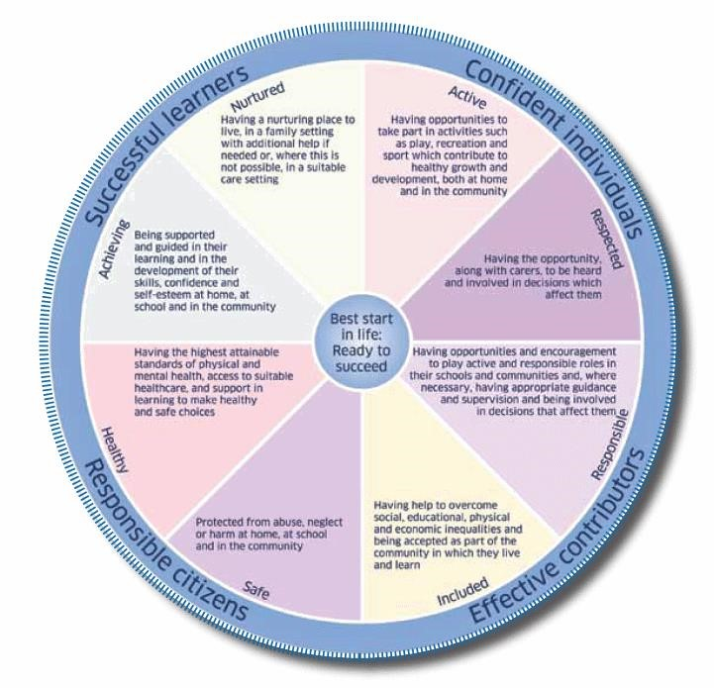

Appendix 2 – Child Protection Flowchart
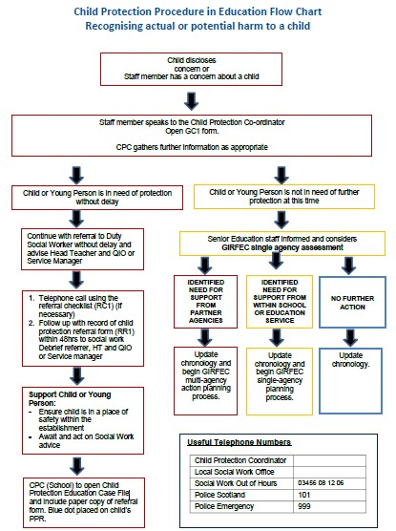

Social Work Office Telephone Number
Turriff 01888 564117
Banff 01261 812001

Or, if out of hours by calling the Social Work Out of Hours Service on 03456 081 206.
Police Scotland can be contacted on telephone number 101.

